New Breeder Agreement | 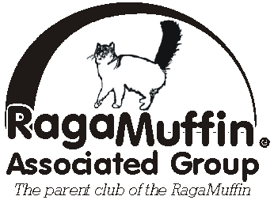

I, _________________________________________________________ agree to the following:
Name: First Middle Initial Last

* To become a RAG-Breeder Member and ACFA-Member and to register my cattery and breeding cats with ACFA

* To send all my Pedigree-information to RAG

* To notify my Mentor and RAG of the birth of any stillborn, dead or deformed kitten

*To notify my Mentor and RAG of any kitten/cat mortality in my cattery.

* To notify my Mentor and RAG of any information I get from kitten-buyers regarding health concerns hinting at or confirming a diagnosis of HCM, PKD or other serious health issue.

* To notify my Mentor of any serious illness occurring in my breeding cats.

* For a period of two years not to place breeding cats with anyone except already established RAG-Breeders and only after consultation with my Mentor for Pedigree-compatibility.

* Not to use RagaMuffins (or the Breed’s full name or parts of it) as foundation cats to create any new Breed(s)

* Not to do any outcrossing during the two year Breeder Apprentice Program. Exceptions to this must be approved in writing by the RAG Board of Directors (or committee appointed by them) and the Mentor of the Apprentice Breeder.

* No member of RAG, whether an Apprentice or full Breeder member, shall make any decisions on behalf of the breed which will effect the Breed and/or fellow Breeders, without first having openly discussed it with all the other RAG members and received approval for the action by the RAG BOD.

* I understand, that not following one or more of these requirements could lead to my exclusion as a RAG-Member

Signed: _____________________________________ Date: ___________________

